**Van Houten Residents from Miscellaneous Uncitable Sources**

These names are gathered from anywhere and everywhere not cited for any other information.

**Charles Hoover Melban**

b. November 3, 1928 in VH

d. July 2, 1937 Died from injuries sustained from getting hit by a car as he jumped away from fireworks on July 2, 1937 in Gardiner, New Mexico.

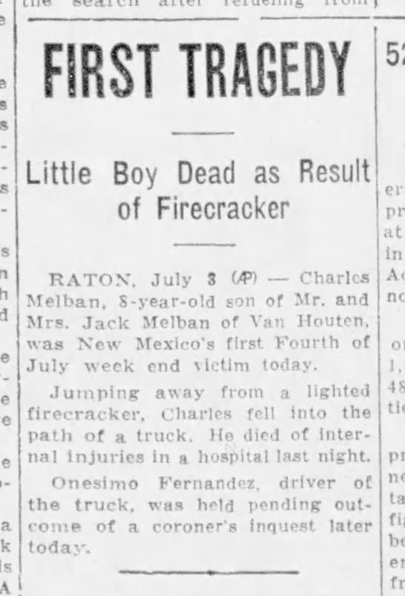

**Margaret Dolores (Schulte) McIlvaine**

b. September 30, 1911 in VH to Stephen Bernard Schulte and Nell Ellen (Kerr) Schulte

Granddaughter of Walter ‘Alt’ Kerr

**Nell Ellen (Kerr) Schulte**

b. November 21, 1886 in Coalgate, Coal, Oklahoma

Daughter of Alt Ker

**Walter B Kerr**

b. June 7, 1867 in Cockpen, Edinburghshire, Scotland

Catcher for the Van Houten Swastikas

**Davina Robertson (Simpson) Melban**

b. May 27, 1903 in Dunfermline, Fife, Scotland

Wife of John R. Melban, married in VH in 1921.

**John Perovich**

b. February 9, 1924 in VH

U.S. Army Air Corps, 1943-45, 2nd Lieutenant

12th president of UNM. Graduated high school in Raton.

**Stanlee Ray Gatti**

b. October 28, 1955 in VH to Larry and Ann Simovich Gatti

"I am half Italian and half Montenegrin.".

He was best man at the wedding of Governor Gavin Newsom to former wife Kimberly Guilfoyle, and designed Governor Newsom’s subsequent Montana wedding to Jennifer Siebel. (Wikipedia)

**Myrtle Elizabeth Wells**

<http://www.rathbun-family.com/History/master%20rathbun-perrine%20family/665.htm>

**James George Kallimani**

Received a Degree of Bachelor of Science in Commerce from the University of Notre Dame, 1949.

<https://scholarship.law.nd.edu/cgi/viewcontent.cgi?article=1115&context=commencement_programs>

**James Bertola**

Student at International Correspondence School. Made an average of 95 percent or better on his lessons in October. From VH